Azure Data Sync POC:
Steps and things to take care of when we have to setup and configure Azure Data Sync.
Pre-requisites for setting up Azure Data Sync.
- Feature does not support Azure MI.
- Hub must be an Azure SQL DB.
- Member database can be Azure/On-Prem Db
  - If On-Prem, then we need to install Local Sync Agent
- Each table must have a primary key.

- Once we had Azure SQL database created in Azure. Go to the newly created database and navigate to ‘Data Management’ and choose ‘Sync to other databases’ as shown in the below screenshot.

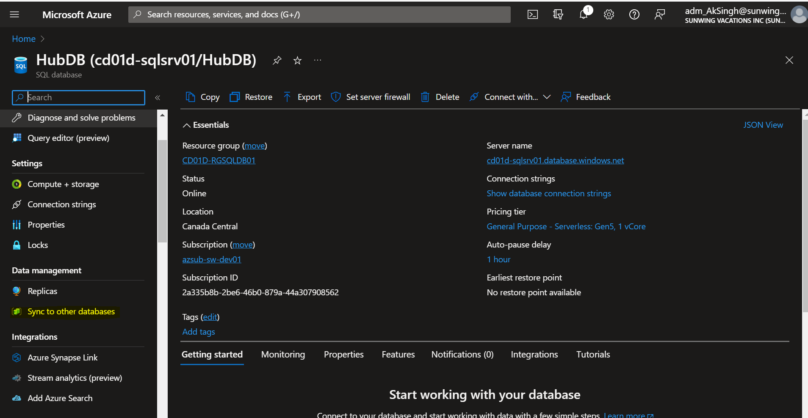

- We then must create a new Sync Group, so click on the option of ‘New Sync Group’ as shown below.

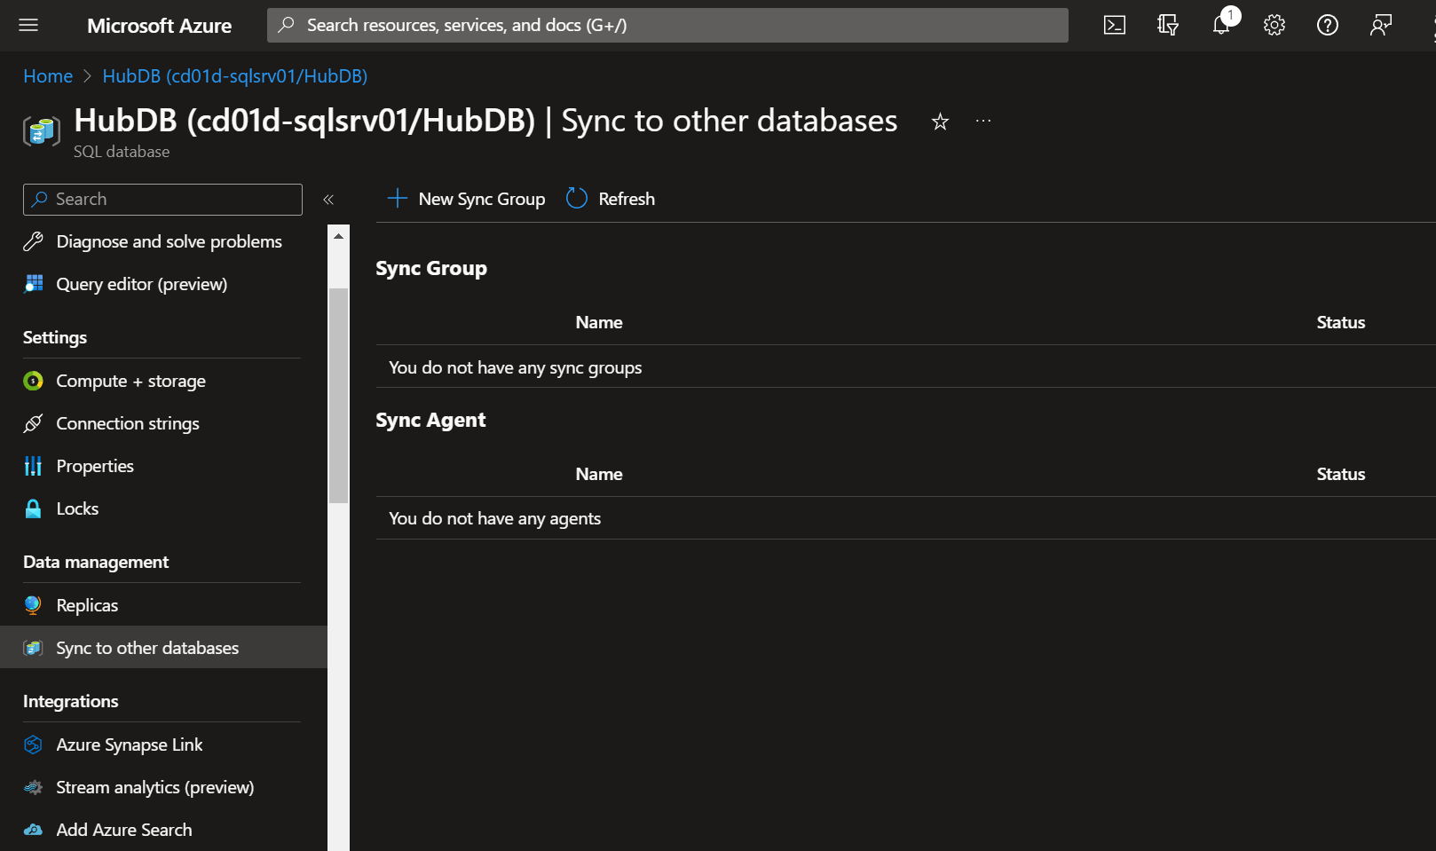

- Give the following inputs (inputs can be changed based on one’s preference) and click OK. With this, the Sync group would be ready.
User account must be created within the database and must have db_owner privileges.
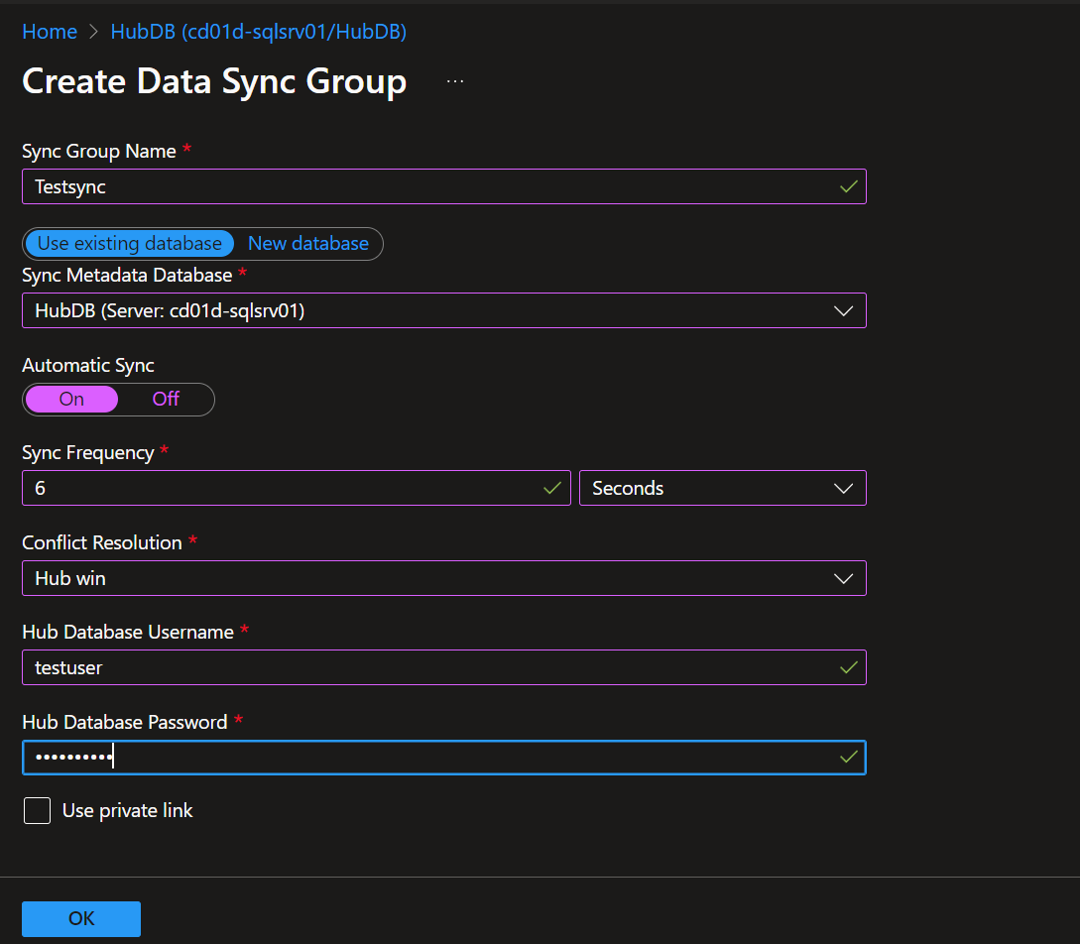

- Now, we need to add member databases that could be an Azure SQL database or On-Prem Database. In our case, it is an On-Prem Database. Click on Add an On-Prem Database

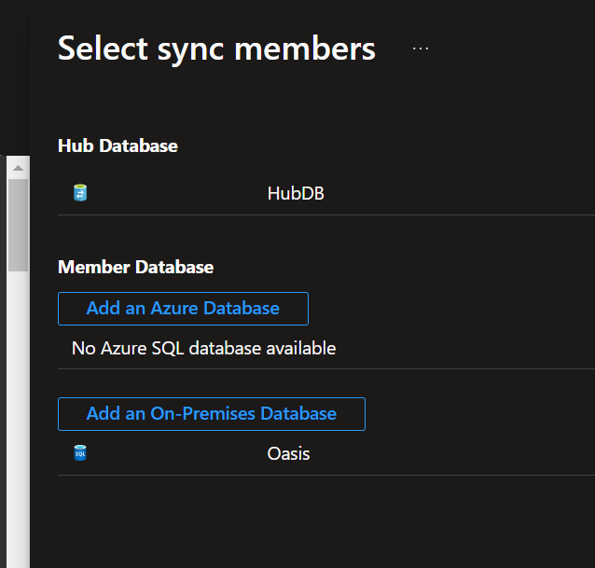

- Upon Clicking, choose the sync agent gateway.

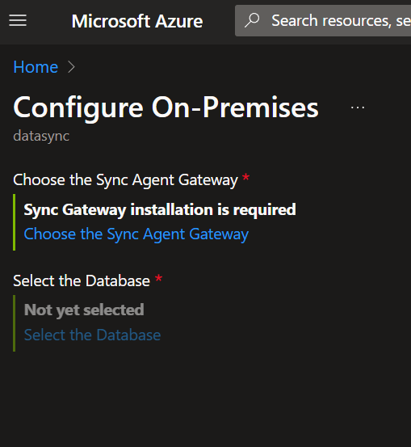

- Setup and configure the Sync agent gateway by following the below steps. We must download the agent setup and install it on the On-Prem machine. Sync agent will help us in syncing the data from the On-Prem to Azure SQL. We need to generate and provide the key from the portal to the Sync Agent on On-Prem
Download the Azure Data Sync Agent and install on the On-Prem machine.
https://www.microsoft.com/en-us/download/details.aspx?id=27693
Account has to be mentioned for Azure Data Sync.
Licensing Information
Installation Details
Account used for Installation

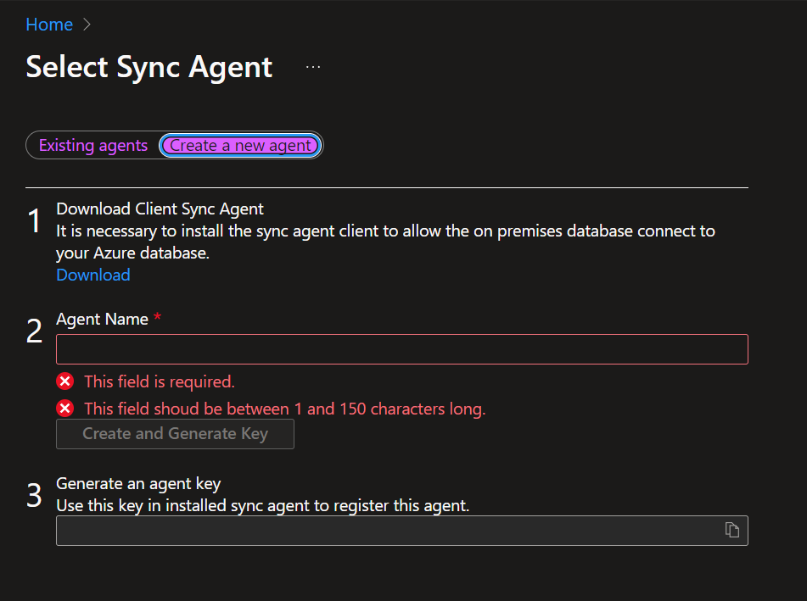

- Launch the Azure Data Sync agent and click on ‘Submit Agent Key’. Provide the key credentials and username and password for the account that has been set up at Azure SQL DB.

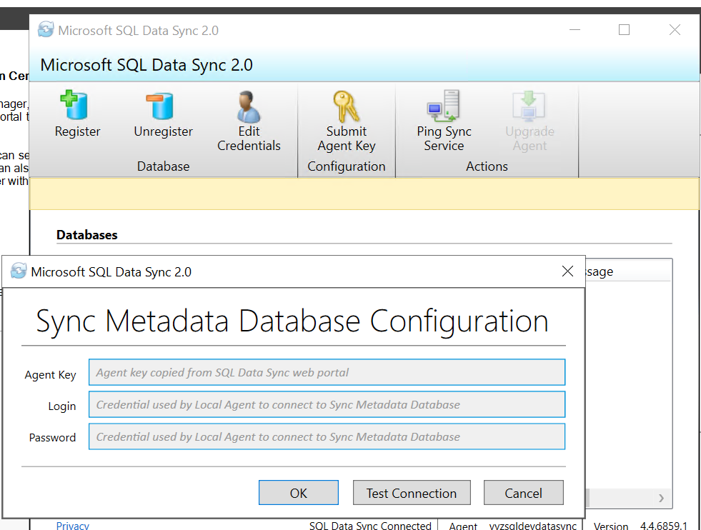

Make Sure the Firewall rules are in place. If not, we might end up seeing this error.
Ports must be mentioned.SR must be mentioned.
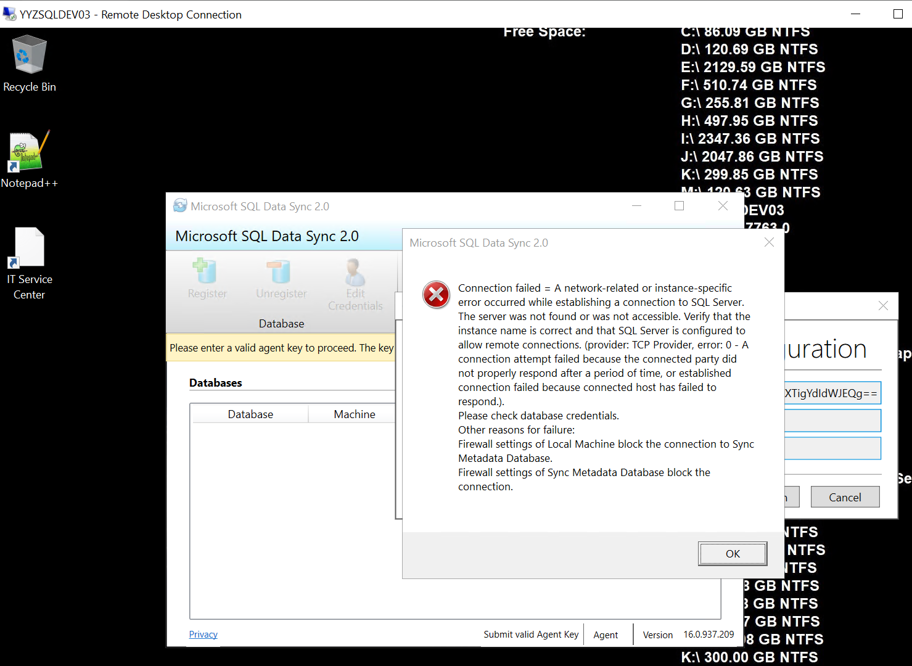

- We might get this error, if the user account at Azure SQL DB is not db_owner and is not a member of DataSync_Admin role.

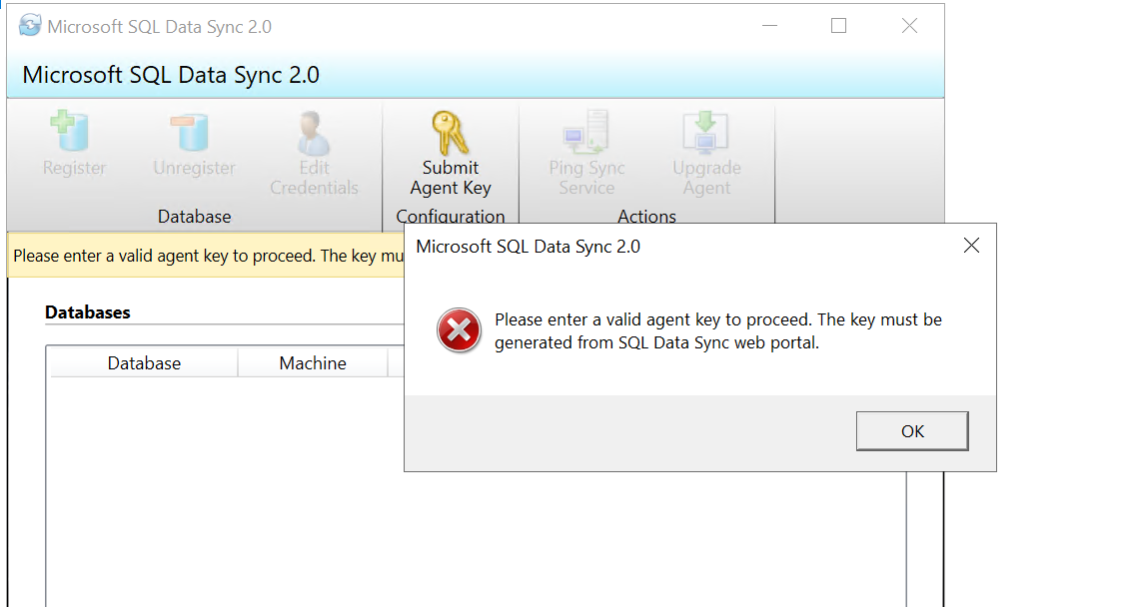

So, Add the user to the respective roles.
EXEC sys.sp_addrolemember 'DataSync_admin','username'
EXEC sys.sp_addrolemember 'Dbmanager', 'username'
EXEC sys.sp_addrolemember 'loginmanager', 'username'

This will resolve the error and agent will start syncing.
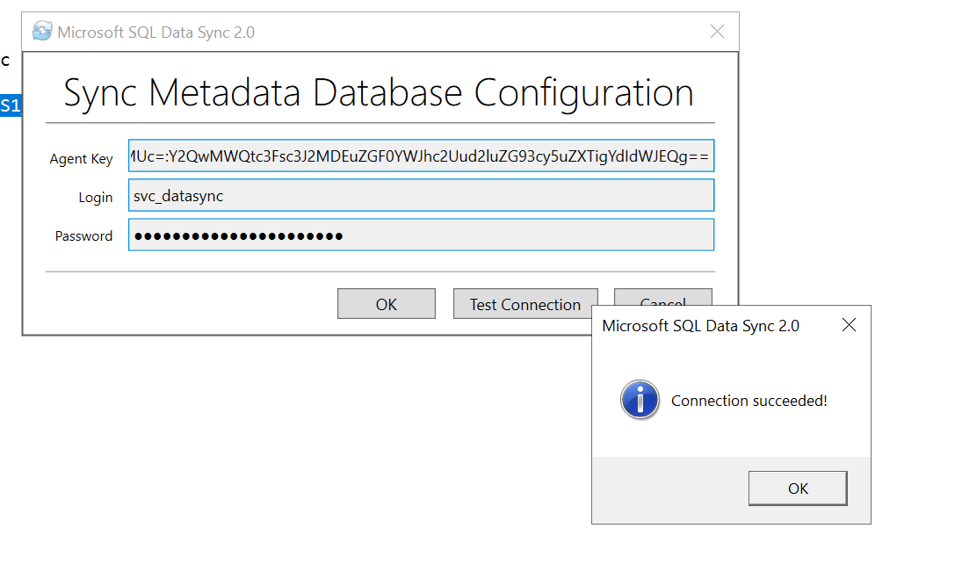

- Register the On-Prem Server and Database details by clicking on register option in the Sync agent.
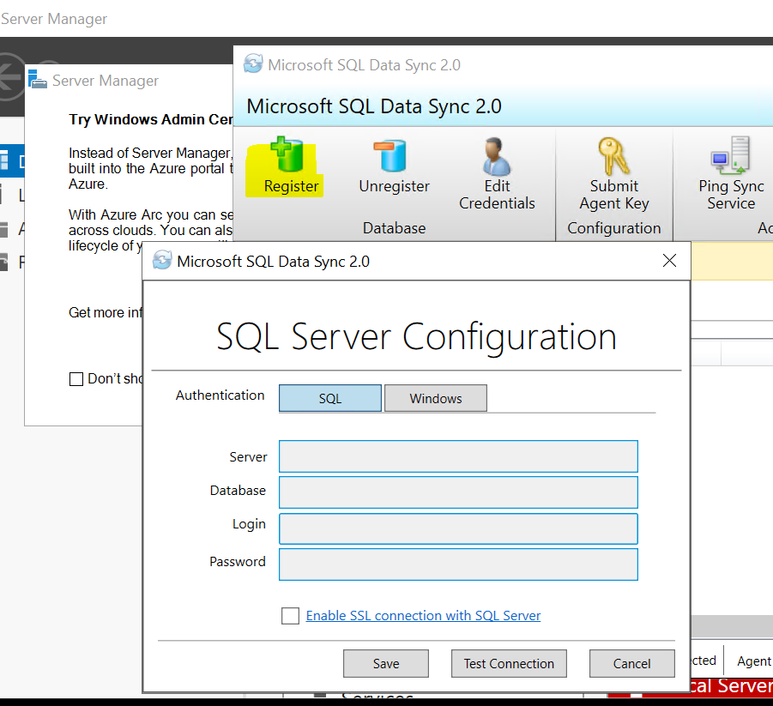

Once the server is added, we can see it in the agent.
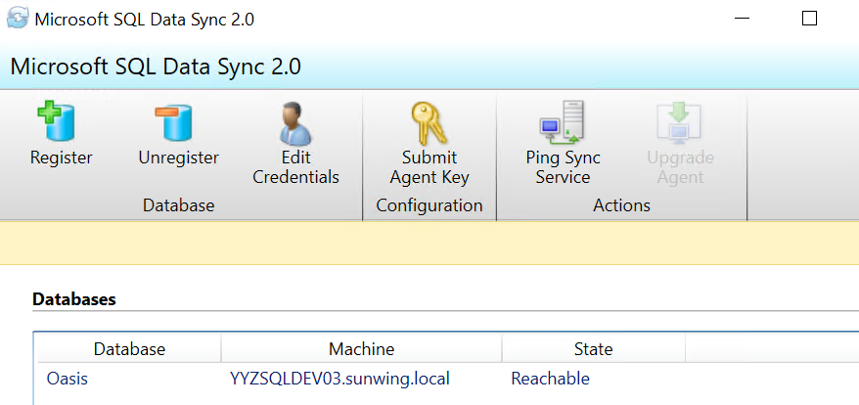

- Go back to the Azure Portal and add the On-Prem Server and Database.
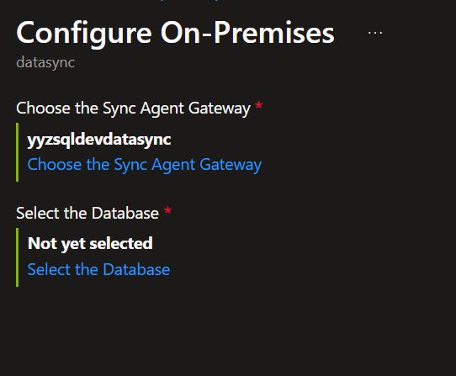
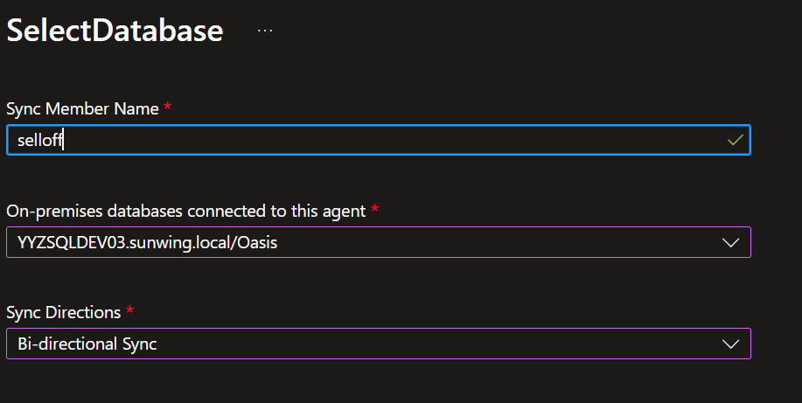

- Once the database has been added, we need to add tables. Tables with Primary keys can only be added.
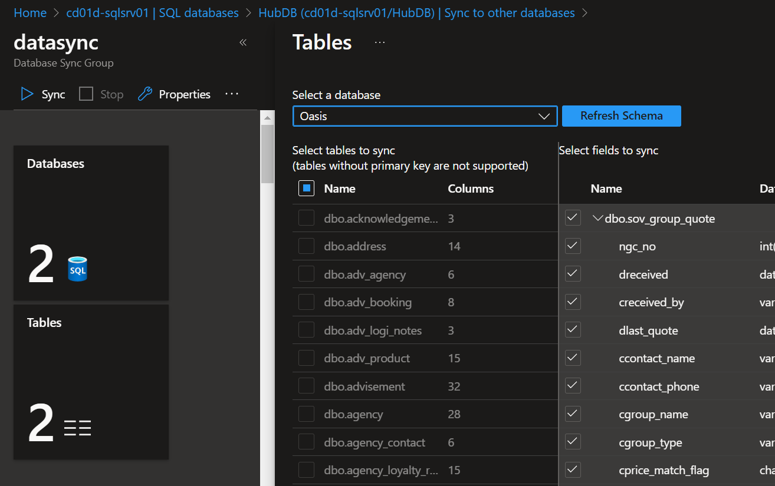

- Choose the tables and choose the columns and click on Save.
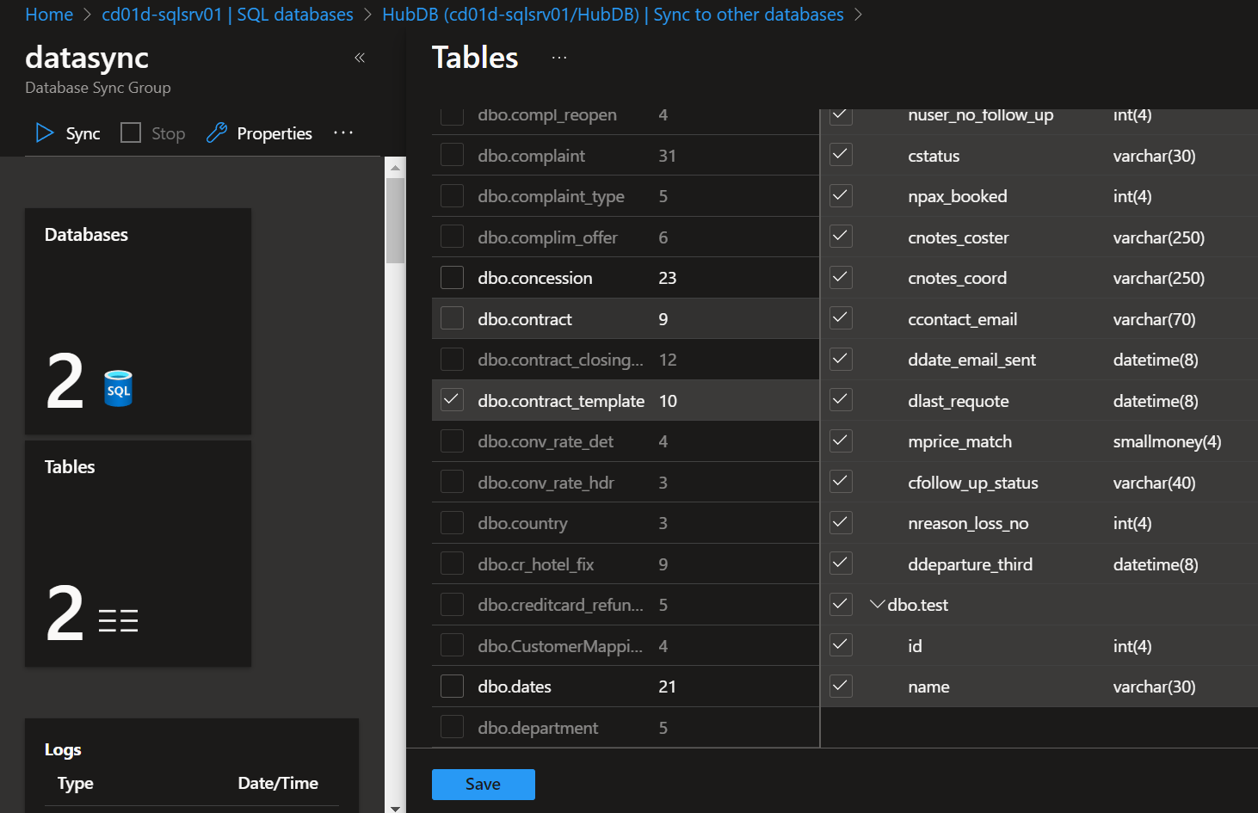

- Once tables are added, it will take some time and then we can see the data on both the server. We can check the logs to get the status.
